Stroke F.A.S.T. Message – Waka Ama Voices
The F.A.S.T. campaign encourages everyone to learn the key signs of stroke and to think F.A.S.T., act fast and look out for each other by calling 111 if they suspect a stroke. Prompt action can save lives - as well as improve recovery.
A stroke happens when a blockage, such as a clot, blocks the blood flow to the brain, or when a blood vessel burst in the brain.
By learning to recognise the symptoms of a stroke you could save a life or brain damage can be reduced and a better outcome achieved!
FACE Is their face drooping on one side? Can they smile?
ARM Is one arm weak? Can they raise both arms?
SPEECH Is their speech jumbled or slurred? Can they speak at all?
TAKE ACTION Call 111 immediately.
If any of the signs of stroke are recognised, don’t wait, call 111
Even if the symptoms go away quickly or don’t cause pain you should call 111 immediately.

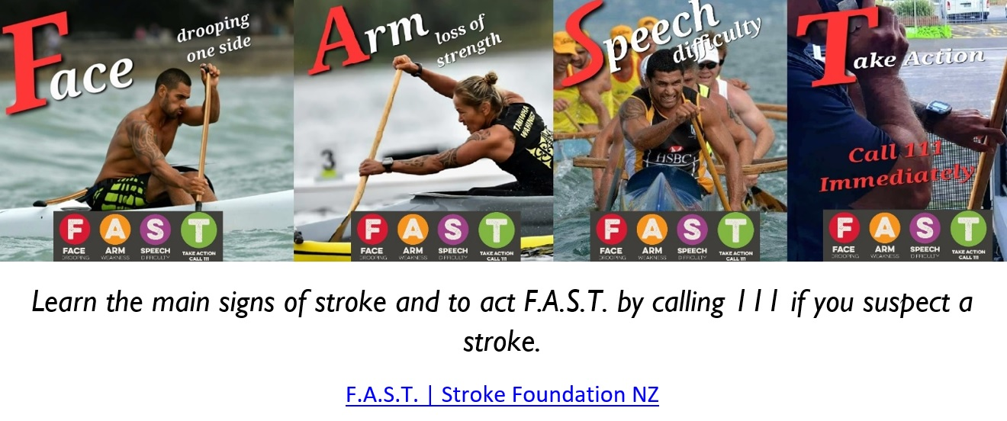

Ko Whakapunake te Maunga
Ko Te Wairoa Hōpūpū Hōngenge Matangirau te Awa
Ko Takitimu te Waka
Ko Ngāti Kurupakiaka te hapū
Ko Ngāti Kahungunu ki te Wairoa te Iwi
Ko Ariana Gordon Glassford toku ingoa
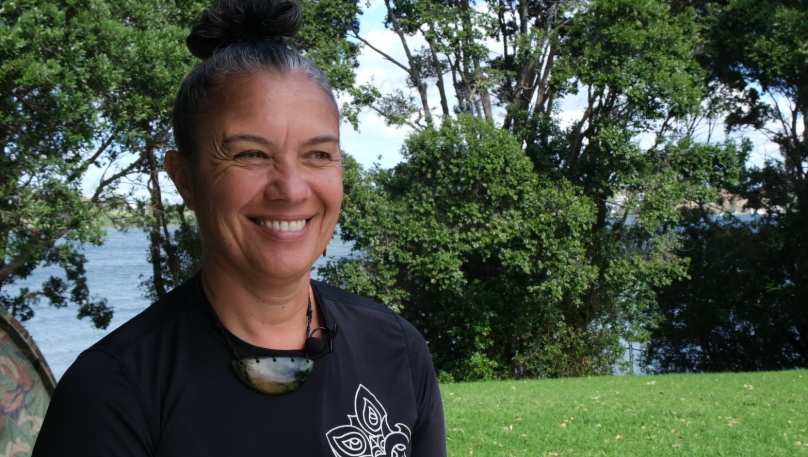

Ariana shares her experience by where both parents have had a ‘stroke’.
The importance of TIME, to receive medical treatment after having a ‘stroke’ and the effect it has on recovery can be seen in this story.
https://youtu.be/p1_U9eLvSZw

Ko Tokatoka Maunga
Ko Kaipara te Awa
Ko Māhuhu ki te rangi te Waka
Te Uri ō Hau Te Hapu
Ko Ngāti Whātua o Kaipara te Iwi
Ko Whitiora Haku toku ingoa

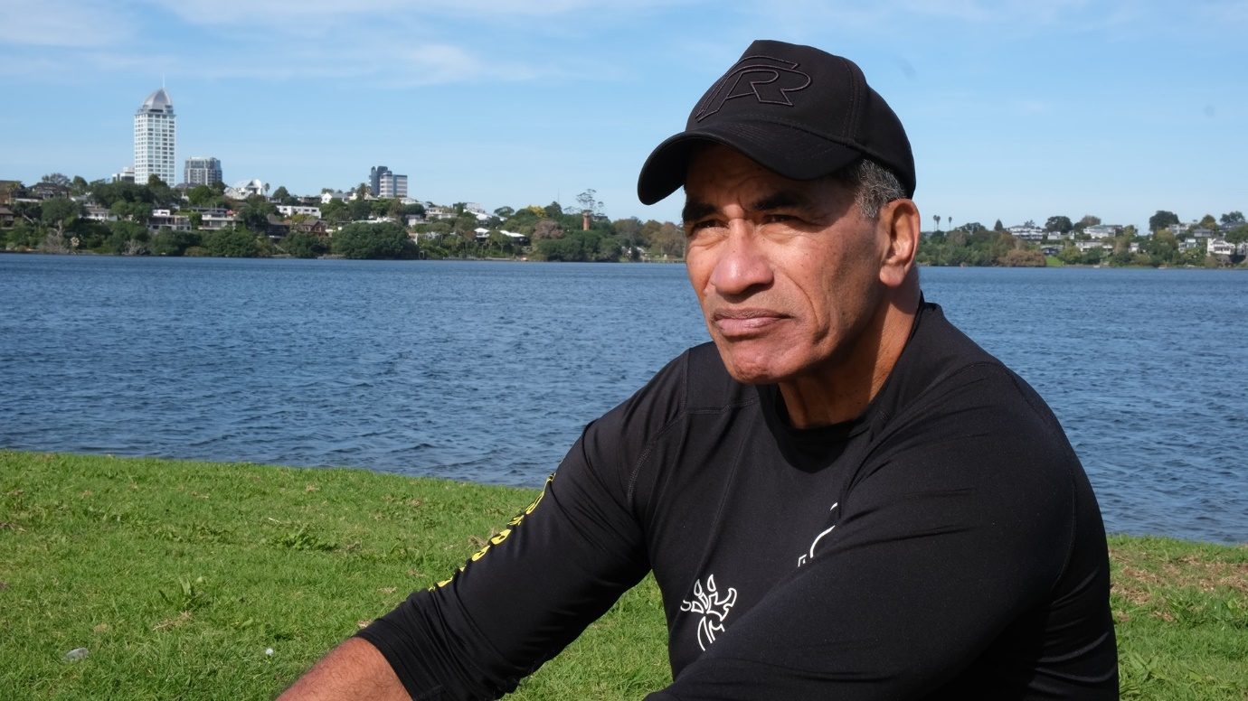

Paul (Whitiora) is a very competitive waka ama paddler with a passion for life, motivated by whanaungatanga and aroha.
Last year Paul experienced a stroke while working out in a gym with his 14- and 15-year-old sons. The quick action of gym members calling for emergency help, he was able to recover almost immediately. The memory of the ‘stroke’ is still emotional for Paul, as he bears the memory of the grief in the eyes of his two sons.
https://youtu.be/xNd4lpPqz1A

